1. Display the lines that contain the word “lp” in /etc/passwd file.

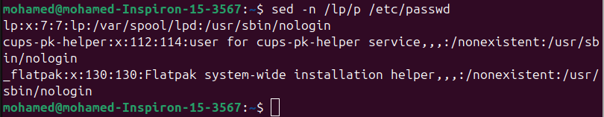

1. Display /etc/passwd file except the third line.



1. Display /etc/passwd file except the last line.

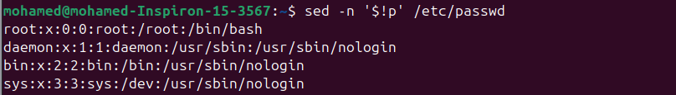

1. Display /etc/passwd file except the lines that contain the word “lp”.

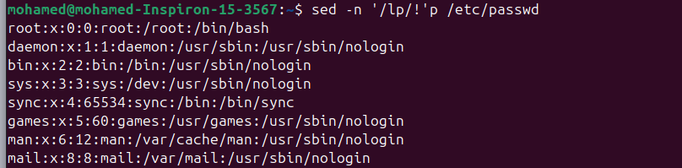

1. Substitute all the words that contain “lp” with “mylp” in /etc/passwd file.

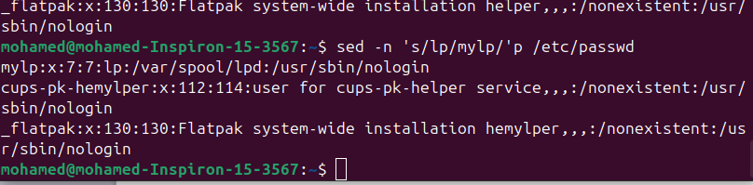

Using awk utility

1. Print full name (comment) of all users in the system.

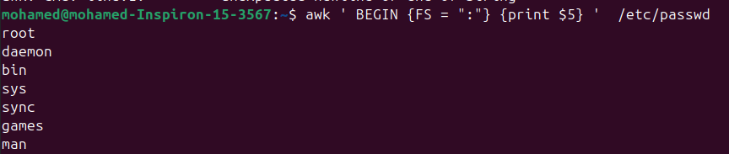

1. Print login, full name (comment) and home directory of all users.( Print each line preceded by a line number)

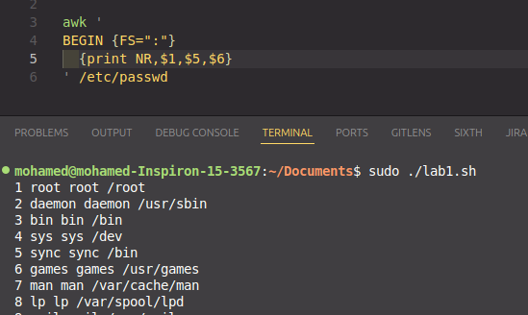

1. Print login, uid and full name (comment) of those uid is greater than 500

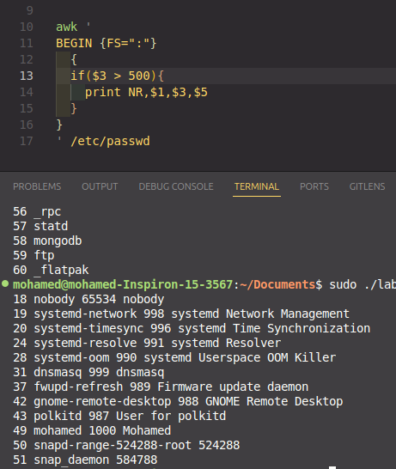

1. Print login, uid and full name (comment) of those uid is exactly 500

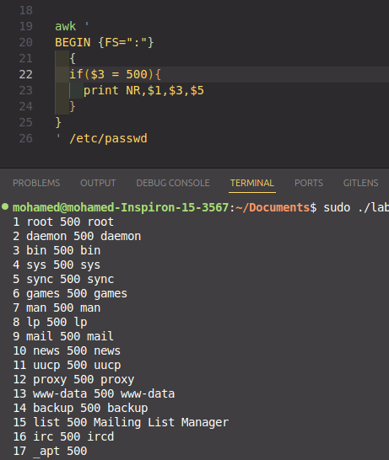

1. Print line from 5 to 15 from /etc/passwd

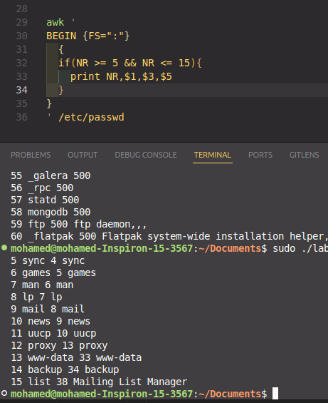

1. Change lp to mylp

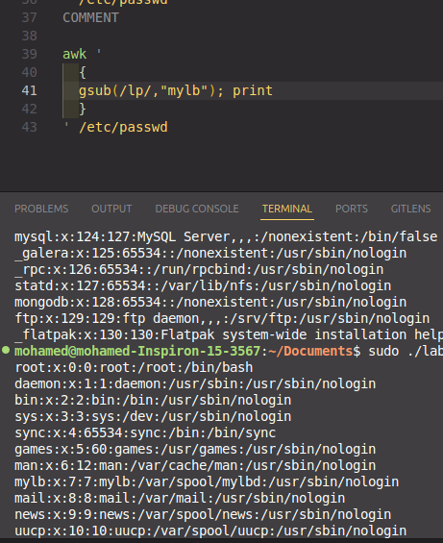

1. Print all information about greatest uid.

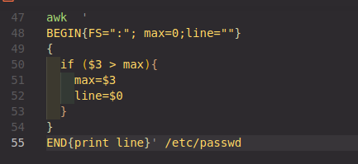



1. Get the sum of all accounts id’s.

